Quantitative Analysis
Student’s Name
Institutional Affiliation

Table of Contents
A 5.1: Chapter 8, Problem 8.1, Chi-Square and Phi (Or Cramer’s V) 3
Process Summary of Chi-Square and Phi for gender and math grades 3
Findings 4
A 5.2: Chapter 8, Problem 8.2, Risk Ratios and Odds Ratios 5
Process Summary 5
Findings 6
A 5.3: Chapter 8, Problem 8.3, Other Nonparametric Associational Statistics 7
Process Summary 7
A 5.4: Chapter 8, Problem 8.4, Cross-Tabulation and Eta 9
Process Summary 9
Findings 11
A 5.5: Application Problem - Crosstabulation and Chi-Square 11
A 5.5 a. Write two research questions and two null hypotheses relating to the 12
following pairs of data, run crosstabs and interpret the results of chi-square and phi (or Cramer’s V) 12
Gender and Marital Status 12
A 5.5. a (2). “age group” and “marital status” 14
A 5.5 b. Write two research questions and two null hypotheses relating to the 15
following pairs of data, run crosstabs and interpret the results of chi-square and phi (or Cramer’s V) 15
A 5.5. b (1). “mathach” and “calc” 15
A 5.5. b (2). “mathach” and “trig” 17

A 5.1: Chapter 8, Problem 8.1, Chi-Square and Phi (Or Cramer’s V)

Process Summary of Chi-Square and Phi for gender and math grades
- Click the folder on the taskbar of the SPSS, choose ahsbdataB.sav file and then click enter to input data into SPSS and access variable view.
- While on the variable view screen, click analyze, then descriptive, then crosstabs.
- Select math grade and move it to row box, then gender to column box.
- Click statistics in the Crosstabs window, then click on chi-square and phi and Cramer’s V, and then continue.
- Click on the cell in Crosstabs window, then click on observed nd expected under counts and columns under percentage, then continues.
- Finally click Okay to display the output.

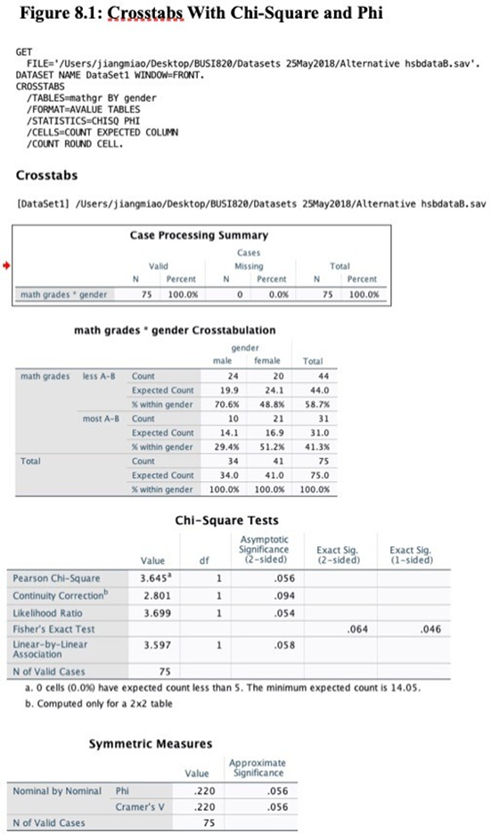

Findings
Chi-square is used to test the significance of a relationship between two nominal variables. he categorical variables in the case is math grade and gender. The Phi or Cramer’s V tests the strength of the relationship between the two variables (Vaske, 2019). From the output presented above, N is 75 which i an indicator that there were 75 participants. Out of the total number of males (34), 24 or 70.6% scored a lower math grade, which was lower than A-B and 10 males or 29.4% scored a higher math grade of more than A-B. The expected count for males with higher math grade is 19.9 and 14.1. On the other hand, out of the 41 females, 20 or 48.8% had a lower grade less than A-B, and 21 or 51.2% had a higher grade mor3e than A-B. The expected count for female with low is 24.1 and high grades are 16.9. Based on the results, more males had a lower grade than females, but this can be assessed on the square to establish whether these differences are by chance (Morgan et al., 2013).
The Chi-Square findings show no cell with a count of less than 5, which is the rule that has to be met when using Chi-Square test. The reported P-value is 0.056, which is less than 0.05, which is an indicator that there is no strong evidence that males and females had a significance difference in achieving low and high scores. The Chi-Square is 3.645, which is an indicator that there is no significant difference between the two categories. There is one degree of freedom at a significance level of 0.05 and threshold of 3.84 (Morgan et al., 2013).
On the other hand, the symmetric gives the strength of the relationship, and the value need to be +/- 0.50 or higher to show a significant relationship (Morgan et al., 2013). The value of Phi is 0.22, which is an indicator of a weak relationship as well as small effect size. Therefore, there is no significance difference in terms of low and high math grades between males and females.

A 5.2: Chapter 8, Problem 8.2, Risk Ratios and Odds Ratios
The following is a calculation risk ratios and Odd ratios for students taking and those who did not take algebra 2.

Process Summary
- To begin click Analyze while on variable view, then descriptive statistics, and finally crosstabs.
- Select Algebra2 and move to rows then math grades and move it to columns.
- The third step is to click on statistics in the Crosstabs window, then Chi-Square and Phi and Cramer’s V, then finally click on Risk and then continue
- Step 4 is to click the cells in Crosstabs window, click observed under counts and rows under percentages then click continue.
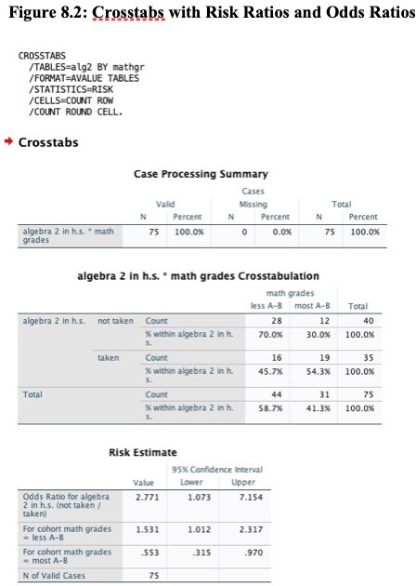
- Click OK to display the output.

Findings
The above findings show the summary statistics, N is 75, which is an indicator that participants had valid data for the two variables under consideration. Crosstabulation table shows that 44 students recorded low math grade, and 28 did not take algebra2. On the other hand, 31 students had a high math grade and 12 did not take algebra2. Risk estimate table shows that the risk ratio for low math grade is 1.531, which shows that for students who did not take math algebra2 has a chance of 1.531 for getting low grades compared to those who did take algebra2. On the other hand, the risk ratio of high math grade A-B is 0.553, which is an indicator that there is a chance of 0.553 for students who did not take algebra2 getting high grades compared to those who took algebra2. The upper and the lower limits are not inclusive of 1, and are greater of less than 1, which shows that the risk ratio has a statistical significance (Morgan et al., 2013). The Odds Ratio is 2.77, indicating the odds of getting a low math grade for students who had not taken algrabra2 are 2.77 higher as those of getting high math grades if they failed to take algebra2. This falls within a lower bound of 1.07 and upper bound of 7.15.

A 5.3: Chapter 8, Problem 8.3, Other Nonparametric Associational Statistics

Process Summary
The variables that will be considered in this case are mother’s and father’s education and Kendall’s tau-b correlation coefficient will be used as a nonparametric measure of the strength and direction of association of the two ordinal variables (Vaske, 2019).
- Click on the analyze while on the variable view screen and select descriptive statistics, then crosstabs
- Select mother’s education revised and moves it to rows, then father’s education and moves it to the column box.
- Click statistics in the Crosstabs window, then click Chi-square, then select Kendal tau=b coefficient under ordinal, then select Phi and Cramer’s V under nominal then continue.
- Click on cells in Crosstabs window, click on observed and expected under the count section and then select total under percentages, then click continue
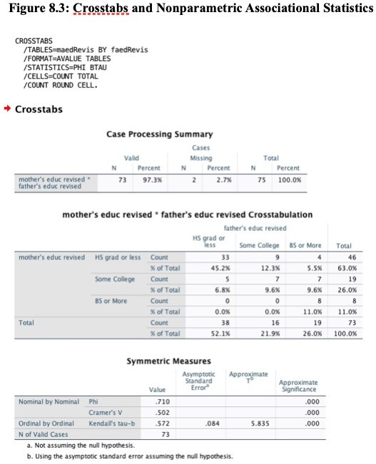
- Click OK to display the output.
The findings above indicate that N is 73, showing that 73 of the participants had valid data for both variables. Kendall’s tau-b falls within a range of -1 and +1, which shows correlation is normal, a value of -1 shows there is perfect negative correlation, while +1 shows a perfect positive correlation, while 0 indicates no correlation. The p-value is less than 0.001, which shows a statistically significant for p<0.05, τb is 0.572, showing that father’s and mother’s education are positively correlated. This indicates that fathers that were highly education were likely to get educated to highly educated mothers, which also applies for mothers (Morgan et al., 2013).

A 5.4: Chapter 8, Problem 8.4, Cross-Tabulation and Eta

Process Summary
- Click on analyze while on the variable view screen, then descriptive statistics and Crosstabs
- Select math achievement and move it to the Rows box and select gender then move it to the column.
- Click on statistics in the Crosstabs, then select Eta, then click continue
- Click on the cells in the cross tabs, then click observed and expected, then continue.
- Click OK to get display as below.

Case Processing Summary
 | Cases
 | Valid |  | Missing |  | Total
 | N | Percent | N | Percent | N | Percent
math achievement test * gender | 75 | 100.0% | 0 | 0.0% | 75 | 100.0%

math achievement test * gender Crosstabulation
 |  |  | gender |  | Total
 |  |  | male | female | Total
math achievement test | -1.67 | Count | 0 | 1 | 1
math achievement test | -1.67 | Expected Count | .5 | .5 | 1.0
math achievement test | 1.00 | Count | 0 | 2 | 2
math achievement test | 1.00 | Expected Count | .9 | 1.1 | 2.0
math achievement test | 2.33 | Count | 0 | 1 | 1
math achievement test | 2.33 | Expected Count | .5 | .5 | 1.0
math achievement test | 3.67 | Count | 1 | 2 | 3
math achievement test | 3.67 | Expected Count | 1.4 | 1.6 | 3.0
math achievement test | 4.00 | Count | 0 | 2 | 2
math achievement test | 4.00 | Expected Count | .9 | 1.1 | 2.0
math achievement test | 5.00 | Count | 3 | 2 | 5
math achievement test | 5.00 | Expected Count | 2.3 | 2.7 | 5.0
math achievement test | 5.33 | Count | 0 | 1 | 1
math achievement test | 5.33 | Expected Count | .5 | .5 | 1.0
math achievement test | 6.33 | Count | 0 | 2 | 2
math achievement test | 6.33 | Expected Count | .9 | 1.1 | 2.0
math achievement test | 6.67 | Count | 0 | 1 | 1
math achievement test | 6.67 | Expected Count | .5 | .5 | 1.0
math achievement test | 7.67 | Count | 2 | 2 | 4
math achievement test | 7.67 | Expected Count | 1.8 | 2.2 | 4.0
math achievement test | 8.00 | Count | 0 | 1 | 1
math achievement test | 8.00 | Expected Count | .5 | .5 | 1.0
math achievement test | 9.00 | Count | 2 | 2 | 4
math achievement test | 9.00 | Expected Count | 1.8 | 2.2 | 4.0
math achievement test | 9.33 | Count | 0 | 1 | 1
math achievement test | 9.33 | Expected Count | .5 | .5 | 1.0
math achievement test | 10.33 | Count | 1 | 3 | 4
math achievement test | 10.33 | Expected Count | 1.8 | 2.2 | 4.0
math achievement test | 10.67 | Count | 0 | 1 | 1
math achievement test | 10.67 | Expected Count | .5 | .5 | 1.0
math achievement test | 11.67 | Count | 2 | 0 | 2
math achievement test | 11.67 | Expected Count | .9 | 1.1 | 2.0
math achievement test | 12.00 | Count | 1 | 1 | 2
math achievement test | 12.00 | Expected Count | .9 | 1.1 | 2.0
math achievement test | 13.00 | Count | 1 | 2 | 3
math achievement test | 13.00 | Expected Count | 1.4 | 1.6 | 3.0
math achievement test | 14.33 | Count | 5 | 4 | 9
math achievement test | 14.33 | Expected Count | 4.1 | 4.9 | 9.0
math achievement test | 14.67 | Count | 1 | 0 | 1
math achievement test | 14.67 | Expected Count | .5 | .5 | 1.0
math achievement test | 15.67 | Count | 2 | 0 | 2
math achievement test | 15.67 | Expected Count | .9 | 1.1 | 2.0
math achievement test | 17.00 | Count | 1 | 4 | 5
math achievement test | 17.00 | Expected Count | 2.3 | 2.7 | 5.0
math achievement test | 18.33 | Count | 1 | 0 | 1
math achievement test | 18.33 | Expected Count | .5 | .5 | 1.0
math achievement test | 18.67 | Count | 1 | 0 | 1
math achievement test | 18.67 | Expected Count | .5 | .5 | 1.0
math achievement test | 19.67 | Count | 2 | 1 | 3
math achievement test | 19.67 | Expected Count | 1.4 | 1.6 | 3.0
math achievement test | 20.33 | Count | 0 | 1 | 1
math achievement test | 20.33 | Expected Count | .5 | .5 | 1.0
math achievement test | 21.00 | Count | 3 | 0 | 3
math achievement test | 21.00 | Expected Count | 1.4 | 1.6 | 3.0
math achievement test | 22.33 | Count | 1 | 1 | 2
math achievement test | 22.33 | Expected Count | .9 | 1.1 | 2.0
math achievement test | 22.67 | Count | 0 | 1 | 1
math achievement test | 22.67 | Expected Count | .5 | .5 | 1.0
math achievement test | 23.67 | Count | 4 | 2 | 6
math achievement test | 23.67 | Expected Count | 2.7 | 3.3 | 6.0
Total |  | Count | 34 | 41 | 75
 |  | Expected Count | 34.0 | 41.0 | 75.0

Directional Measures
 |  |  | Value
Nominal by Interval | Eta | math achievement test Dependent | .301
Nominal by Interval | Eta | gender Dependent | .626

Findings
The case Processing summary indicates that N is 75, which shows all 75 participants had data that was valid for both variables. The cross tabulation table shows the expected count of participants in each cell and the eta is .301 and is medium to large effect size, which is an indicator female were more likely to achieve more in math’s compared to their male counterparts (Morgan et al., 2013).

A 5.5: Application Problem - Crosstabulation and Chi-Square
Chi-Square is used to establish whether there is a statistically significant relationship between nominal variables. This makes it easier tom conduct an evaluation of nominal independent variables and multiple groups. The Chi-Square is based on assumptions such as that the value of the cell expected need to be 5 or more in at least 80% of the cells, with no cell expected to have a value less than one (Morgan et al., 2013). There are a minimum number of observations for each category that should be in place for Chi-Square to be used to ensure validity of p-value. The variables to consider in A5.5a are marital status, gender and age, which are nominal and dichotomous variables. On the other hand, A5.5b Mathach is a nominal variable, while trigonometry is nominal variables. In this regard, Chi-Square can be used to measure the relationship in both cases (5a and 5b). Phi is used to ascertain the strength of the relationship where significant Chi-Square findings have been obtained. Both 5a and 5b can utilize Phi. For table larger than 2X2, Cramer’s V is appropriate statistic for testing significance to establish the strength of the relationship between the variables (Morgan et al., 2013). In case one variable has two categories, and another more than two, Phi is equal to Cramer’s V. In this case, Phi can be used to test the strength of the association between the pairs of the variables.

A 5.5 a. Write two research questions and two null hypotheses relating to the

following pairs of data, run crosstabs and interpret the results of chi-square and phi (or Cramer’s V)

Gender and Marital Status
Research Question: Is marital status different between male and female student?
Null hypotheses: There is no difference in marital status for male and females.
The processing table shows that N is 49, which indicates out of the total participants had valid data for the test, and one participant was missing from the test. Out of the 26 males, 19 falls under the single and divorced category, while only 7 were in marital status. Males who were single were 16.4, while 9.6 were married. On the other hand, 23 females participated of which 12 females or 52% fall under the single and divorced category, and 11 females or 48% were married. Expected count for single females is 14.6 and 8.4 are married. Males were more likely to be single or divorced compared to their female counterparts. However, whether the difference was by chances can be ascertained in the Chi-Square table. The Chi-Square table indicates that no cell had a count of less than 5, and meets the condition for using chi-square (Morgan et al., 2013). The p-value is 0.13, which is greater than 0.05, suggesting lack of strong evidence to support hypothesis that males and females differed in terms of marital status. Chi-Square value of 3.84 is expected at 5% significance level and 1 DF. The Chi-Square obtained is 2.29, which further proves lack of significant difference between the two categories. Finally, the symmetric tables provide measure to assess the strength of the relationship, which should be between +/-0.5 or more for large size on relationship. Phi can be used in this case since both variables have two levels. Phi should range from -1 to +1, 0 shows no relationship, -1 is perfect negative relationship, while +1 is perfect positive relationship. Phi in this case ranges between 0.2 and 0.29, which indicates a weak positive relationship (Morgan et al., 2013). This further confirms that there is no significant difference between males and females in terms of marital status. Therefore, the null hypothesis should be upheld.
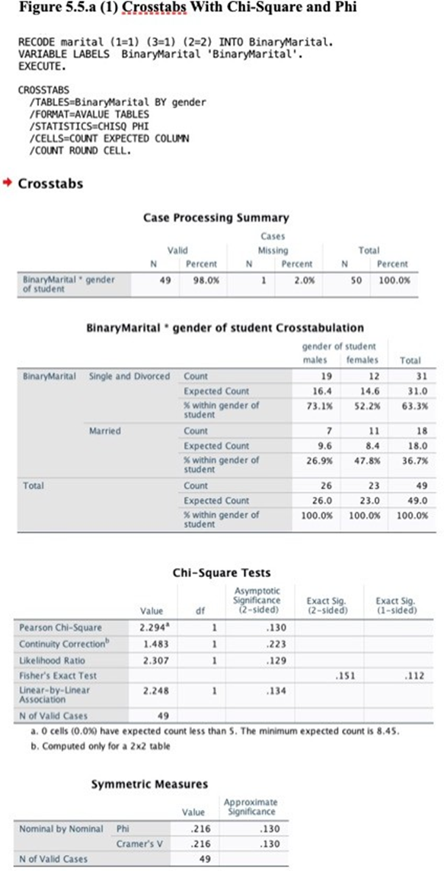

A 5.5. a (2). “age group” and “marital status”
Research Question
Are students of different age groups differing in terms of their marital status?
Null Hypothesis
Students of different age groups do not differ in terms of material status?
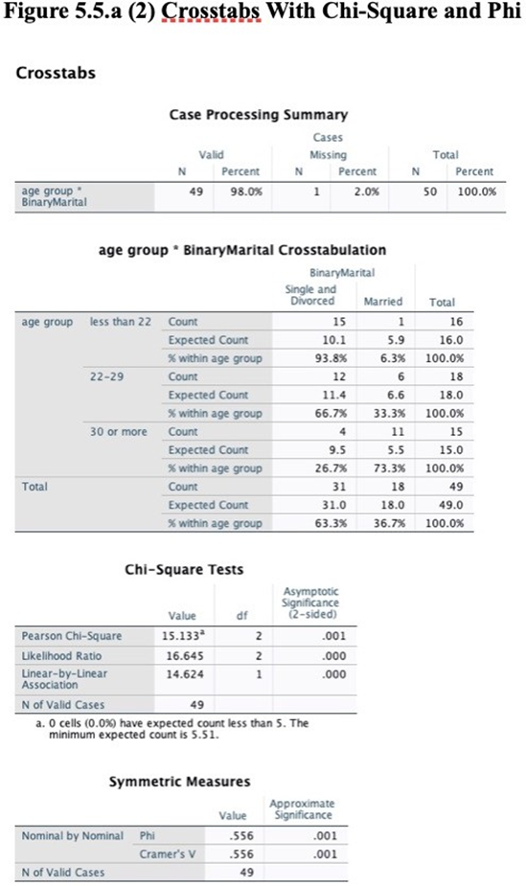

The processing summary show N is 49, which is an indicator that 49 participants had valid data, while one is missing. 15 students out of the 16 below 22 years were either single or divorced; only 1 was married. Those who are single and divorced are 10.1, and 5.9 are married. Students between 22 and 28 years are 18, 12 or 66.7% were single, while the other 6 or 33.3% were married. The single and divorced students between 22 and 28 years expected count is 11.4 and those married are 6.6. Students aged 30 and above years were 15, out of which 4 were single and divorced, while 11 were married. The expected count within the category of 30 and over years for the single and divorced students is 9.5, and married is 5.5. Students below 22 years had a majority who were single and divorced; while those above age of 30 years a majority had been divorced. The above statistics need to be determined whether the differences were by chance based on the Chi-Square test table. No cell had a count less than 5, which is the valid condition for using Chi-Square test. P-value in this case 0.01, which is less than 0.05, indicating that there is strong evidence to support different student ages differ in terms of their marital status. At one degree of freedom and p<0.05, the Chi-Square is 3.84, the chi-Square in this case is 15.133, which shows a significant difference between the two categories. The symmetric measures table indicates the strength of relationships, which should be between -1 and +0.5 to show strong relationship. In this case Cramer’s V is used to test the statistical significance and shows the association between the two categorical variables. The Cramer’s V ranges from 0 to 1, and the above shows that its value as 0.556, which shows high association and large effect size. Therefore, students in different ages differ significantly in their marital status. Therefore, the null hypothesis should be rejected.

A 5.5 b. Write two research questions and two null hypotheses relating to the

following pairs of data, run crosstabs and interpret the results of chi-square and phi (or Cramer’s V)

A 5.5. b (1). “mathach” and “calc”

Research Question
Do students of low and high match achievements differ on whether they take calculus in high school or not?
Null hypotheses:
Students of low and high match achievement do not differ whether they take calculus in high school or not.
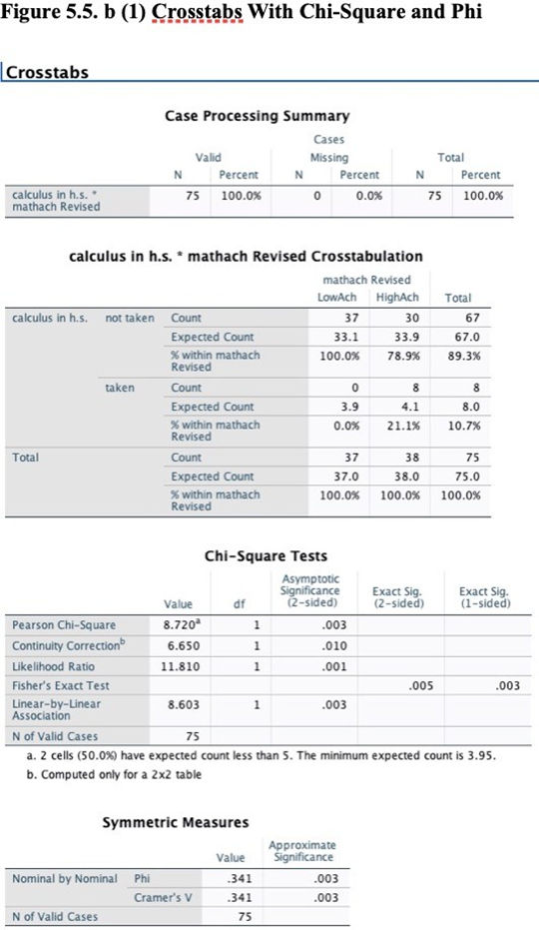
The processing summary table N is 75, showing all participants data was valid. The cross tabulation table shows students who took and those who did not take calculus with group of low match achievement and those within group of high match achievement. The results from the table shows that large portion of students of low match achievement did not take calculus 100%, while 78.9% of students in the high achievement category did not take calculus. Chi-Square can be used to determine whether the observed or expected differences were by chance. From the Chi-Square table, no cell count less than five setting stage for use of chi-square test. P-value is 0.03, which is less than 0.05, showing significant difference and strong evidence that supports the claim that low and high match achieving students differed in taking calculus in high school. The Chi-square value in this case is 8.72, which shows significant differences between the two categories. The symmetric measure table shows a Phi value of 0.341, which is an indicator of moderate relationship and relatively small effect size (Morgan et al., 2013). The student of high match and low match achievements differ in whether they take calculus in high school or not. Therefore, the null hypothesis should be rejected.

A 5.5. b (2). “Mathach” and “trig”
Research question:
Do students of high match achievement and of low match achievement differ on whether the take trigonometry in high school or not?
Null hypotheses:
Student of high match achievement and those of low match achievement do not differ in whether they take trigonometry in high school or not.
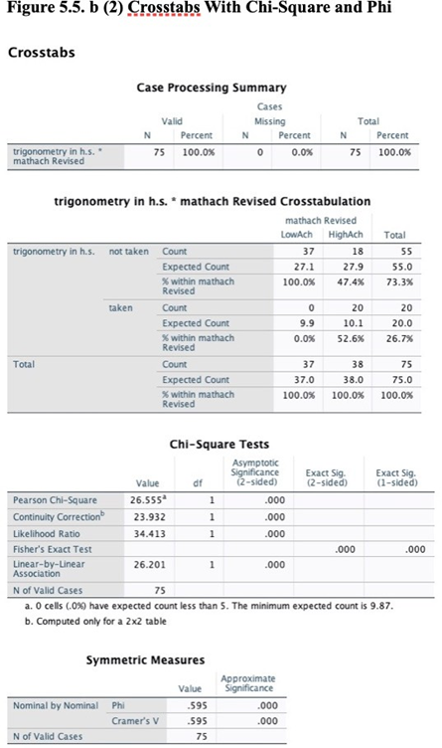
The summary table shows that N is 75, and all participants had valid data. Cross tabulation shows the number of students who had taken and those who had not taken trigonometry within low match achieving students and those within high match achieving students. The expected count of low match achieving and high match achieving students who had taken or did not take trigonometry. High number of students (100%) in the low match achievement group had not taken trigonometry compared to the high match achievement group where 47.4 percent had not taken trigonometry. The differences could be assessed whether they happened by chance could be determined using Chi-square test (Morgan et al., 2013). The P-value in the chi-square table is 0.001, and less than 0.05, showing there is significant difference between low match achievement and high match achievement students in taking trigonometry in high school or not. A chi-square value of 26.56 shows the difference between the two groups is significant (Barceló, 2018). The symmetric measures show the strength of the relationship between the two categories, using Phi, for variables that have two levels. The Phi range is -1 to +1, where in this case the Phi value is 0.595, showing a strong association between the two categories and on large effect size. The student of high or low match achievement differs on whether they take trigonometry in high school or not.

References
Barceló, J. A. (2018). Chi‐Square Analysis. The Encyclopedia of Archaeological Sciences, 1-5.
Morgan, G. A., Leech, N., Gloeckner, G., Barrett, K. C. (2013). IBM SPSS for Introductory Statistics (5th Ed.). Routledge. https://bookshelf.vitalsource.com/#/books/9781848729827/cfi/3!/4/4@0.00:0.00
Vaske, J. J. (2019). Survey research and analysis. Sagamore-Venture. 1807 North Federal Drive, Urbana, IL 61801.

